- Create on Bash script to check if a directory is available or not.
Steps:
- Accept directory name as input.
- Use if [ -d "$dir" ] to check if directory exists.
- Print result.
#!/bin/bash
read -p "Enter directory name: " dir
if [ -d "$dir" ]; then
echo "Directory $dir exists."
else
echo "Directory $dir does not exist."
fi
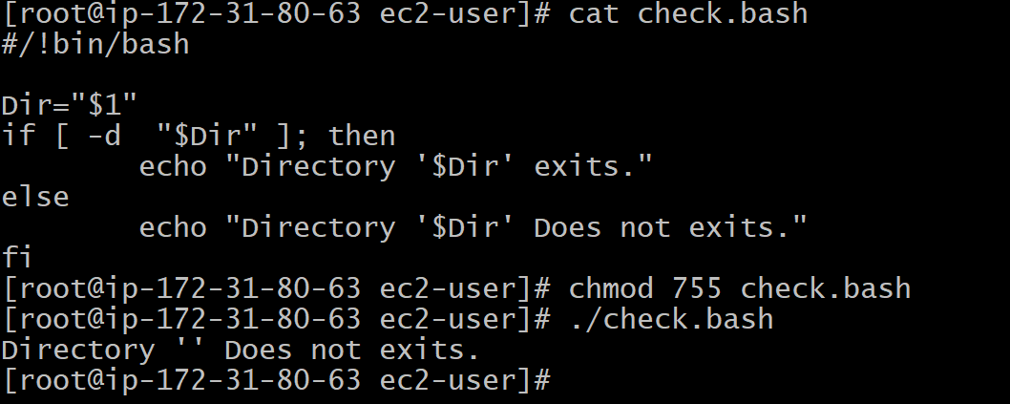
2) Create a bash script which will create multiple files.

Steps:
- Accept number of files and prefix from user.
- Use for loop to create files.

#!/bin/bash
read -p "Enter file prefix: " prefix
read -p "Enter number of files: " num

for i in $(seq 1 $num)
do
touch "${prefix}_${i}.txt"
done

echo "$num files created with prefix $prefix."
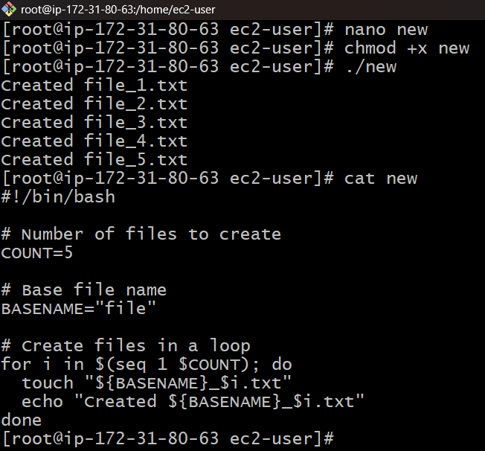
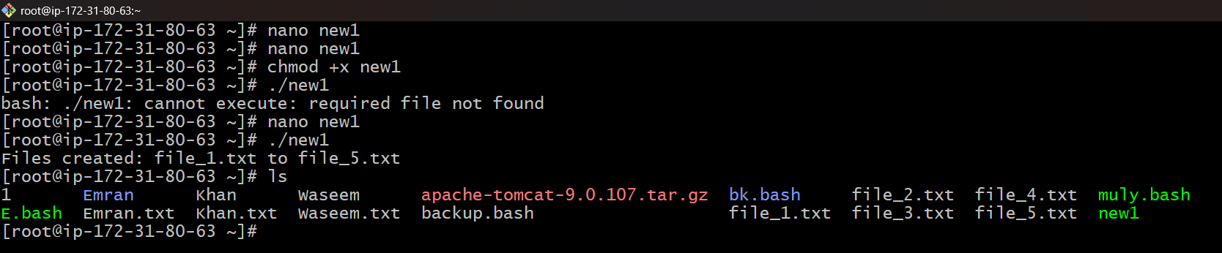
3) Create a bash script to take backup of a directory.

Steps:
- Accept source directory and backup destination.
- Use tar command to compress and create a backup file.
#!/bin/bash
read -p "Enter source directory: " src
read -p "Enter backup directory: " dest

if [ ! -d "$dest" ]; then
mkdir -p "$dest"
fi

backup_file="$dest/backup_$(date +%F_%H-%M-%S).tar.gz"
tar -czf $backup_file $src

echo "Backup completed: $backup_file"
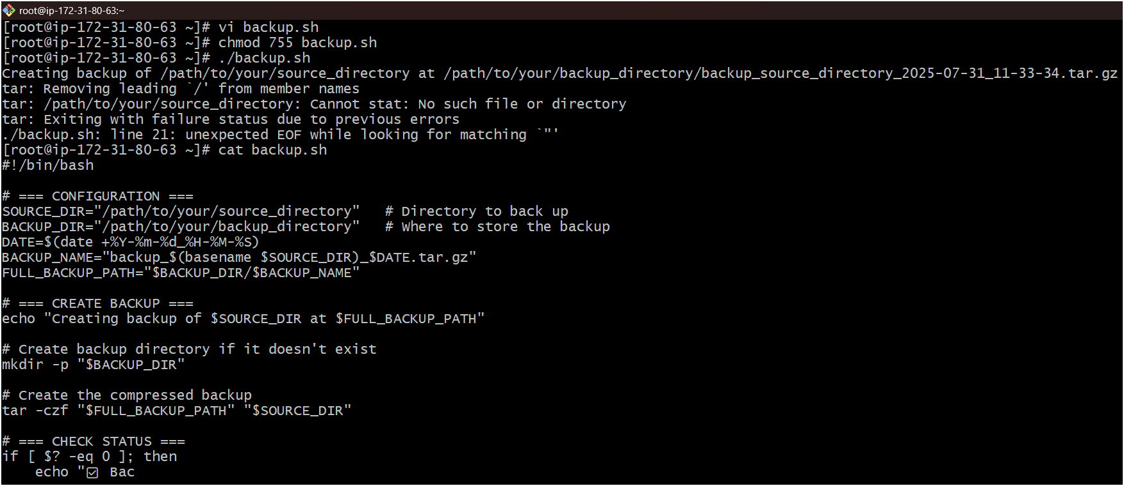
4) Create a bash script to install nginx in ec2 server.
Steps:
- Update packages.
- Install nginx using package manager.
- Enable and start nginx service.
#!/bin/bash
sudo yum update -y # For Amazon Linux/CentOS
sudo yum install nginx -y
sudo systemctl enable nginx
sudo systemctl start nginx
echo "Nginx installed and started successfully."
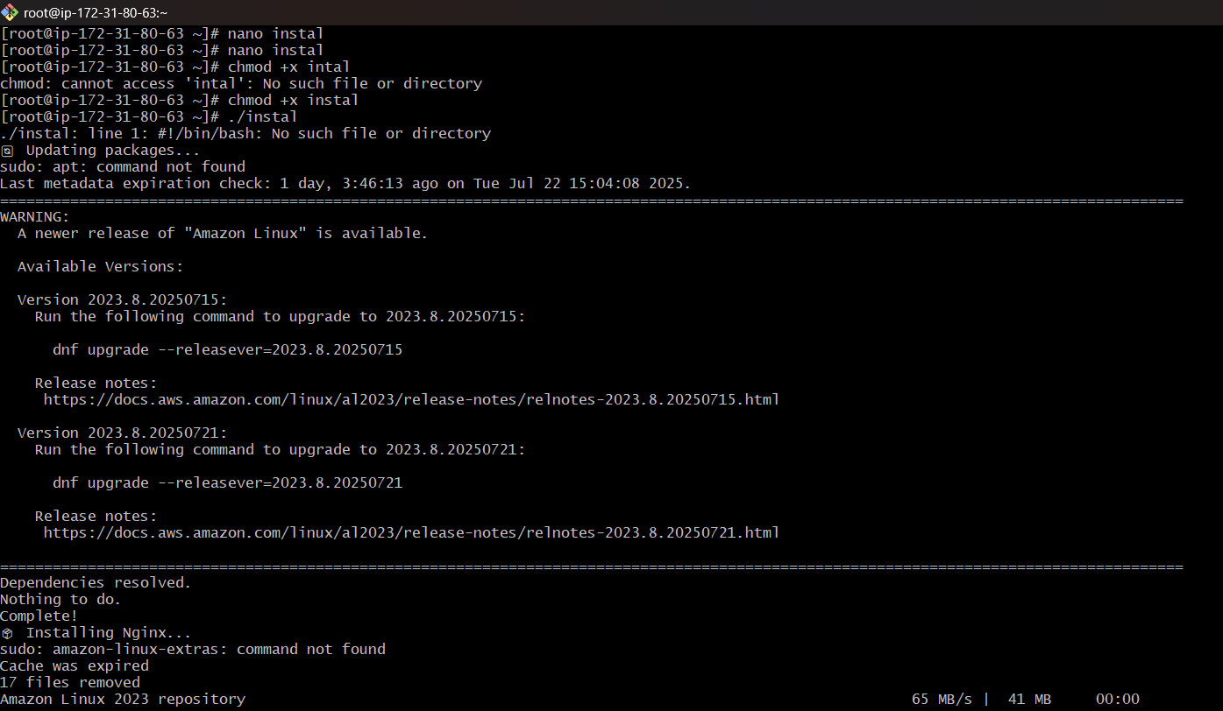
5) Create a bash script to install ApacheTomcat in ec2 server.
Steps:
- Download Tomcat tar file.
- Extract in /opt/.
- Start Tomcat.
#!/bin/bash
cd /opt
wget https://downloads.apache.org/tomcat/tomcat-10/v10.1.20/bin/apache-tomcat-10.1.20.tar.gz
tar -xvzf apache-tomcat-10.1.20.tar.gz
mv apache-tomcat-10.1.20 tomcat
chmod +x /opt/tomcat/bin/*.sh
/opt/tomcat/bin/startup.sh
echo "Tomcat installed and started on port 8080."
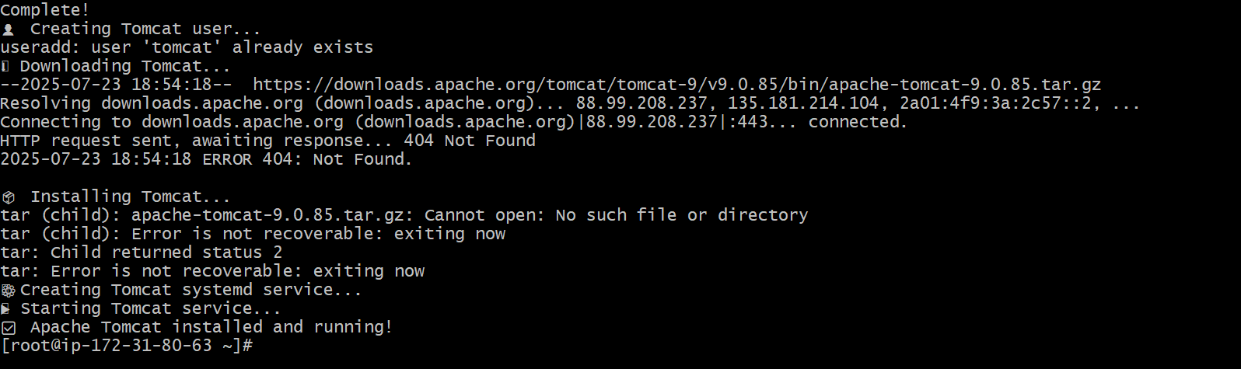
6) Create a bash script to check list if nginx service is running or not,if not running then script should start the service.
Steps:
- Use systemctl is-active nginx.
- If not active, start service.
#!/bin/bash
status=$(systemctl is-active nginx)
if [ "$status" = "active" ]; then
echo "Nginx is running."
else
echo "Nginx is not running. Starting nginx..."
sudo systemctl start nginx
fi
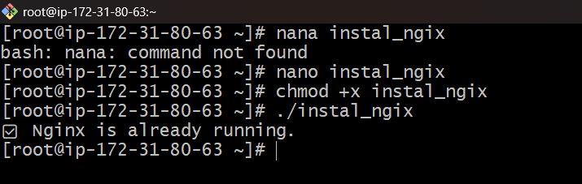
7) Create a bash script for calculator.
Steps:
- Accept two numbers and an operator.
- Use case for arithmetic operations
#!/bin/bash
read -p "Enter first number: " a
read -p "Enter second number: " b
read -p "Enter operation (+, -, *, /): " op

case $op in
+) echo "Result: $((a + b))" ;;
-) echo "Result: $((a - b))" ;;
\*) echo "Result: $((a * b))" ;;
/) echo "Result: $((a / b))" ;;
*) echo "Invalid operation" ;;
esac
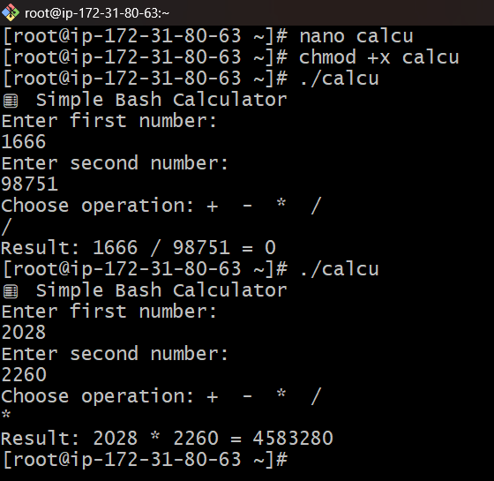
8) Create a bash script to check if directory is avaialble or not,if not then create a directory.
#!/bin/bash
read -p "Enter directory name: " dir
if [ -d "$dir" ]; then
echo "Directory exists."
else
mkdir "$dir"
echo "Directory created: $dir"
fi
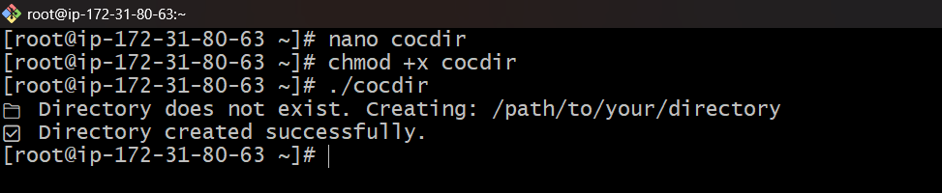
9) Create bash script to delete last 3 lines for a file.
Steps:
- Use sed to remove last 3 lines.
- Overwrite file.
#!/bin/bash
read -p "Enter file name: " file
sed -i -e :a -e '$d;N;2,3ba' -e 'P;D' $file
echo "Last 3 lines deleted from $file."
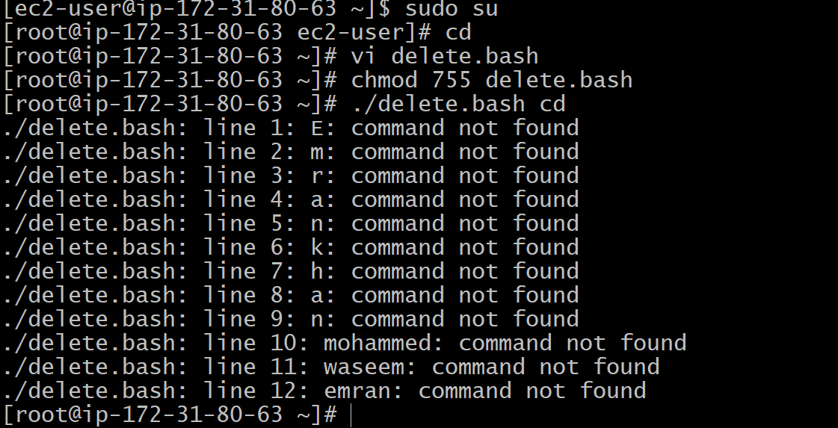
10) Bash script to monitor cpu and if it is more than 80% then send email notification.
Steps:
- Use mpstat or top to get CPU usage.
- If usage >80, send email using mail
#!/bin/bash
cpu_usage=$(top -bn1 | grep "Cpu(s)" | awk '{print $2 + $4}')
threshold=80

if (( ${cpu_usage%.*} > threshold )); then
echo "CPU usage is above $threshold%: $cpu_usage%" | mail -s "CPU Alert" your-email@example.com
fi
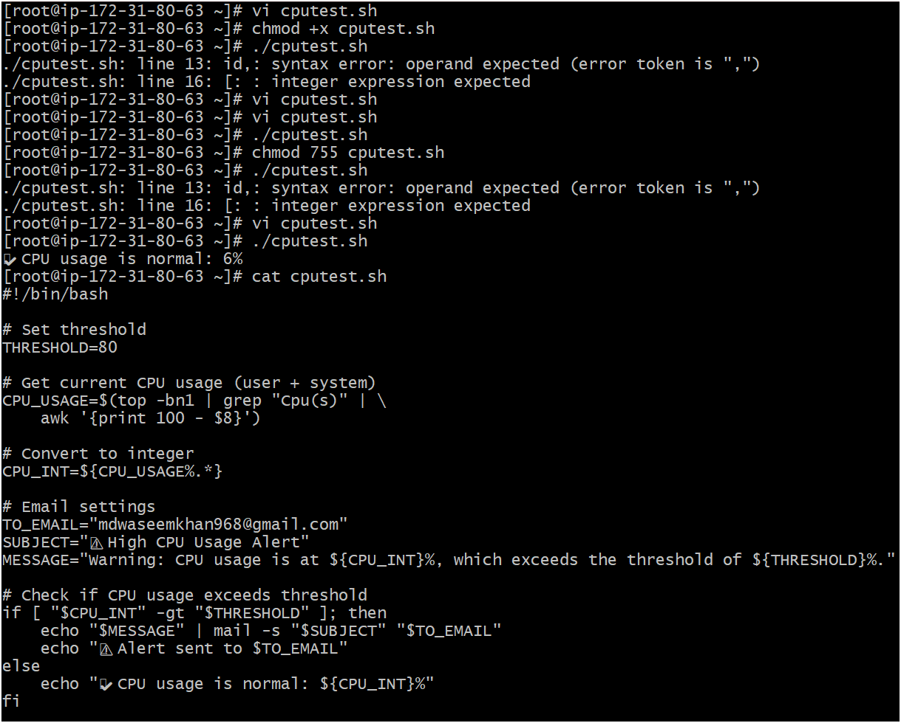
11) Bash script to monitor disk space and if it is more than 80% then send email notification.
Steps:
- Use df command.
- If usage >80%, send email.
#!/bin/bash
threshold=80
df -h | grep '^/dev/' | while read line; do
usage=$(echo $line | awk '{print $5}' | sed 's/%//')
if [ $usage -gt $threshold ]; then
echo "Disk usage is above $threshold%: $usage%" | mail -s "Disk Space Alert" your-email@example.com
fi
done
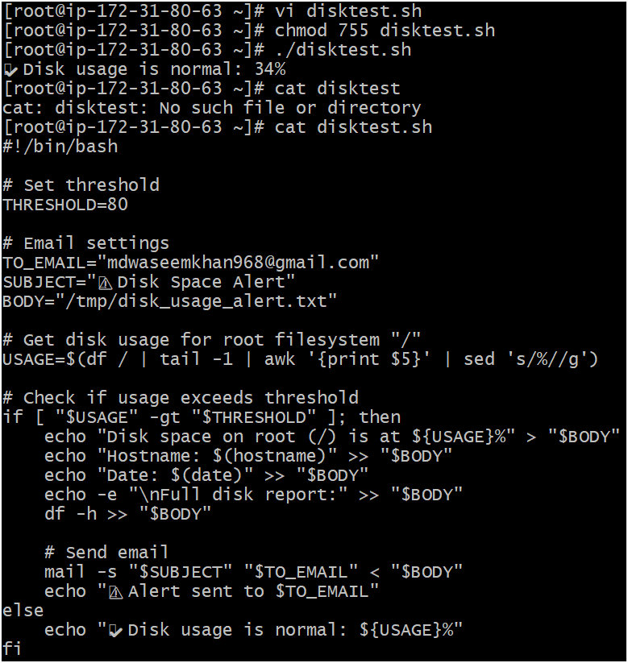
12) Bash script to monitor memory and if it is more than 80% then send email notification.
Steps:
- Use free command.
- Calculate percentage.
- If >80%, send email.
#!/bin/bash
threshold=80
mem_used=$(free | grep Mem | awk '{print $3/$2 * 100.0}')

if (( ${mem_used%.*} > threshold )); then
echo "Memory usage is above $threshold%: $mem_used%" | mail -s "Memory Alert" your-email@example.com
fi
